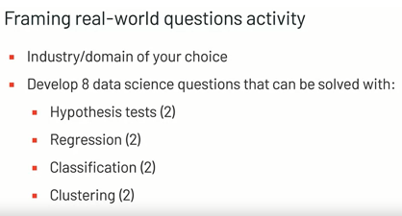

Hypothesis Test-1

Last year, I used 50 kg of fertilizer for one acre of land. This year, I used 75 kg. The height of the wheat planted this year will be longer than last year.

Hypothesis Test-2

Last year, I used 50 kg of fertilizer for one acre of land. This year, I used 75 kg. This year, more grains will be obtained from a cultivated ear of wheat compared to last year.

Regression-1

Considering that I have 10 years of data on expenses such as water, electricity, labor, fuel, etc. on a wheat planted land and my sales price with these expenses, I can make a sales price estimation with the expenses made this year.

Regression-2

We have 10-year wheat harvest information according to meteorological data such as precipitation, precipitation, humidity, temperature, light and shade conditions. According to the meteorological conditions of the current year, we can make this year's yield forecast.

Classification-1

By collecting appricotss from an acre of land with an appricot tree, I can classify them according to their size and set a separate price for each classification.

Classification-2

By collecting apples from an acre of land with an apple tree, I can classify them according to their size and set a separate price for each classification.

Clustering-1

I have land in 10 different places, one acre each. I can decide what to plant on each land by taking soil samples from these lands separately and having them analyzed and clustering according to soil type.

Clustering-2